Royal Brompton & Harefield Hospitals Charity-funded Fellowship Guidance

Background
The Research Office are launching their third round of Research Fellowships funded by the Royal Brompton and Harefield Hospitals Charity. Applications are invited from non-medical staff who wish to undertake either a pre-doctoral or post-doctoral fellowship.

Purpose
The key aim of these fellowships is to provide salary support for staff to undertake up to 12 months of research in order to develop their research skills and produce data to win further funding.

Available Funding
A £150,000 fund is available to support non-medical staff who can apply for up to £50,000 per submission for either a pre-doctoral or post-doctoral fellowship. The fellowship can be held on a part-time basis but must not exceed more than 12 months in duration. Funding can be used to cover anything you require to fulfil your project including salaries, consumables, equipment, publication fees, conference fees, and patient and public involvement (PPI).

Eligibility
To be eligible to apply you must meet all of the following criteria:
- Employed at Royal Brompton and Harefield hospitals Clinical Group at time of applying.
- Project must be sponsored by the Royal Brompton and Harefield hospitals Clinical Group, part of Guy’s and St Thomas’ NHS Foundation Trust.
- Be working as non-medical professional.
- Must not have previously been awarded this fellowship.
- Must have your application costed by the Research Development Team.
- Plan to undertake research that will benefit patients and/or staff at RBHH.
- Can demonstrate how you intend to use the fellowship to apply for further research funding.
- Your proposed research project must not involve animals.
- Have approval and sign off from your line manager.
- Be a UK resident.

Previously unsuccessful applicants are welcome to apply again provided their application fully addresses any feedback received on their initial application.

Application Process
Please submit to research.grants@rbht.nhs.uk as a PDF file by the deadline of midnight on Monday 14 June 2021. In the subject of the email please include your name and “Charity Fellowship”.

Late applications will not be considered.

Projects must start before 31st December 2021. Please note that HRA and ethics approvals must be obtained before your start date.

Key contact for advice on Costs
Laura Henderson, Research Development Manager l.henderson@rbht.nhs.uk

Key contact for advice on Patient and Public Involvement & Engagement
Zahra Aden, Research Development Associate z.aden@rbht.nhs.uk

To avoid any conflict of interest, the Research Office is unable to provide advice or guidance on your application other than costs. Please discuss this with your line manager.

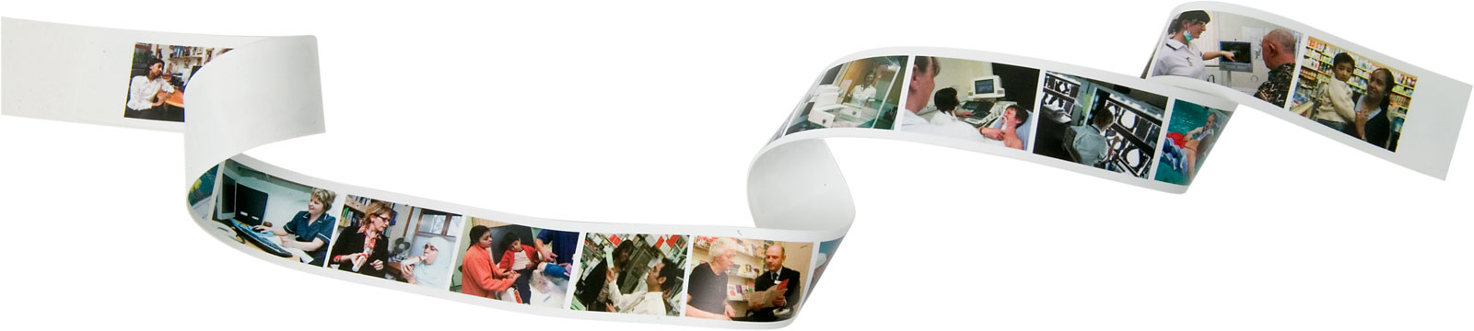
Research Design Service London

Tips for Writing a Lay Summary

Content
- Reviewers need to be able to quickly appreciate the importance of the topic that is being proposed e.g. there is a need or a deficiency in current treatment/technology.

- Focus on the relevance, the application or the benefits (particularly patient benefit), of your proposed research. Why is the work important?

- The lay summary should try to outline what the research project is aiming to do. This ideally should include a summary of aims, background, design/ methods and dissemination (check with funding stream guidance on what is expected)
Style
- Those reviewing your application in a peer review process are not necessarily experts in your topic area; it’s not only lay members of the panel that will find your lay summary useful.

- Write simply and directly, think about the structure. The structure should assist in making the lay summary easy to read (e.g. bullet points, short paragraphs)

- Avoid technical and scientific terms (or explain them in simple language)

- Avoid acronyms and jargon. If you do use one of them explain it.

- Avoid nominalizations e.g. change instances of ‘utilisation’ to ‘using’. Use Anglo Saxon words, rather than Latin derived words.

- Don’t turn verbs into nouns. ‘She was engaged in the construction and installation of instruments.’ She built and installed instruments.

- Short, simple sentences. Sentences should be less than 25 words long.

- Don’t use a long word where a short one will do. Examples: endeavour… try, facilitate… help, consequently… so, advantageous… helpful.

- Write as you would speak. Keep your language punchy, clear and colourful. (Imagine you are explaining your work to a stranger with no science background. Write down exactly what you would say, and tidy up the punctuation later.)

- Find someone who isn’t in your field to read over the summary. Get feedback on your draft from colleagues, supervisors, and at least one non-specialist friend. See what questions they have and ask them to explain back to you what they thought you were communicating.

